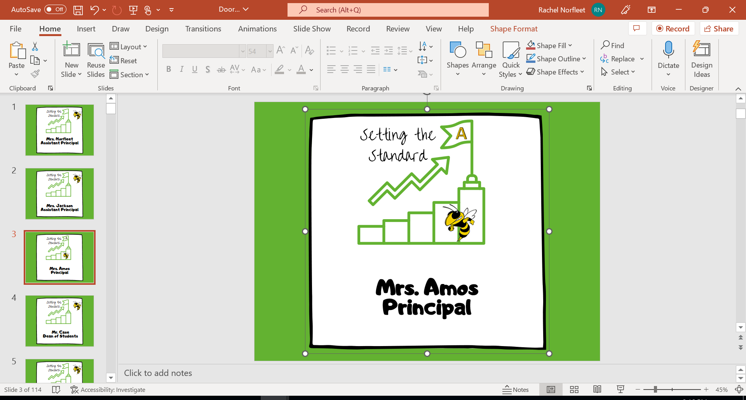
Half Day
1st period – 9:00-9:24
2nd period – 9:28-9:50
3rd period – 9:54-10:16
4th period – 10:20-10:42
5th period – 10:46-11:08
6th period – 11:12-11:34
7th period – 11:38-12:40
1st lunch – 11:38-12:08
2nd lunch – 12:08-12:40

